**House.**

This is a structure that houses your citizens, controlling your population. Your population affects how many troops you can train, the ability to further upgrade resource plots, and your gold production rate.

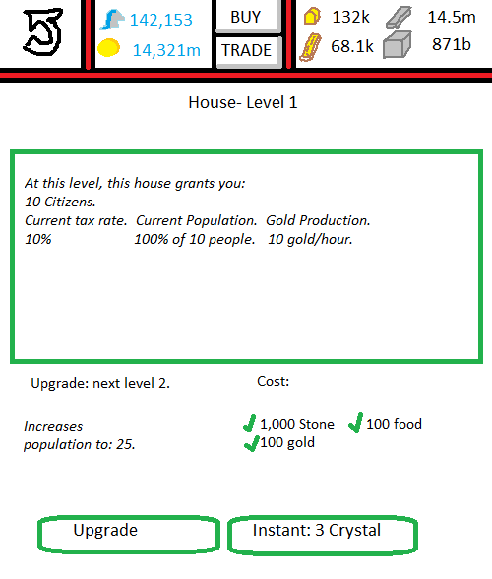

**User Interface: Main Base.**Selecting the house opens a mini-menu. 2 options are given:  
 1. Go to house.  
 2. Upgrade.

**User Interface: House.**There are no special functions that exist with this building.  
‘Upgrade’ will be ghosted if you do not have the correct resources. If you do, and you click it, your building will go into the building queue.   
‘Instant: 3 crystal’ will instantly upgrade your house to level 2, without a build queue, and will deduct 3 crystal from your balance.

**Graphics in use:**GIMB_032. (1) House. Graphic of house from level 1 to 4.  
GIMB_033. (2) House. Graphic of house from level 5 to 9.  
GIMB_034. (3) House. Graphic of house from levels 10+.

**Variables in use:**VS_H001. Variable of your first house. Can be up to 999 variables (theoretically).